**CPSC 1160: Wk1HW**

**Due: As indicated by submission link**

**Total Marks: 10**

**Instructions – PLEASE READ**

1. This work is to be done individually.
2. You should submit only one version via D2L. Check instructions from TA regarding what to submit (zip/just code). Code files must always be included.
3. Keep a copy of everything you submit in some online storage (such as google drive, one drive, dropbox, iCloud, …) that is accessible by you only.

# EXERCISES

Each one of the problems below are exercises from the 1150 textbook – Introduction to Java Programming, 10th edition.

You will find author’s solutions (java code) to each one of these problems along with this file. You may chose to use your own solution to these problems from 1150 course or the solutions provided here.

**Your tasks for each problem:**

1. Run the Java code.
   1. Give the program inputs and note down corresponding outputs.
2. Translate the Java code to C++
   1. Use the cheat sheets
3. Run the C++ code
   1. Give the program same inputs you gave to the Java program and ensure C++ program is behaving the same way as the Java program
4. Submit C++ code
   1. Take note of announcement from our marker Peter Tse regarding additional requirements such as formatting, comments etc.

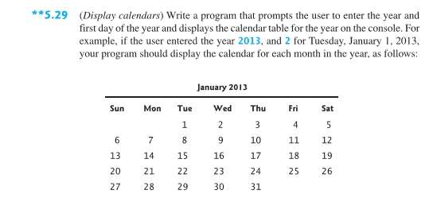

...

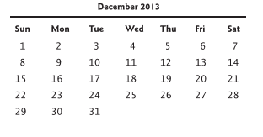

Ignore alignment. Assume all months will be displayed as shown by the Java



